DATA SCIENCE MINOR PROJECT REPORT

CONTENTS OF THE REPORT
- Cover page
- Declaration
- Certificate
- Acknowledgement
- Table of Content

1. Introduction
2. Source of dataset
Dataset Link:
3. EDA process
4. Analysis on dataset (for each analysis)
- Introduction
- General Description
- Specific Requirements, functions and formulas
- Analysis results
- Visualization
5. Conclusion
6. Future scope
7. References

Other Conventions

- Please note the case of letters in the cover page: The 3rd line is 16 pt bold and other lines are 12 pt. The page is centred. Department and Institute names are bold.
- All the matter contained in the report should be typed in MS word (1.5 spacing) Times New Roman, 12 pt or equivalent with other software.
- Figures and tables may be inserted in the text as they appear or may be appended in order.
- Table of Content shall be in well hyperlinked
- List of figures and tables shall be maintained with captions in MS word.
- List of references shall be appended at the end.
- References shall be in IEEE format
- Total Number of pages with A4 size paper shall be minimum 30 pages and maximum 80 pages.
- Hard copy of report must be available with each student on the day of evaluation.
- In addition to Hard copy of reports e-copy shall also be submitted. An e-copy of the report shall be submitted by the student to respective teacher on their emails.

DATA SCIENCE TOOLBOX: PYTHON PROGRAMMING
PROJECT REPORT
(Project Semester January-April 2025)

"IMDb Insights: Analyzing 5000 Top-Rated Movies with Python"

Submitted by
Ravi Kumar
12323421
Bachelor of Engineering (BTech)
INT375

Under the Guidance of
Gargi Sharma (29439)

Discipline of CSE/IT

Lovely School of Computer Science Engineering

Lovely Professional University, Phagwara

CERTIFICATE

This is to certify that Ravi Kumar bearing Registration no. 12323421 has completed INT375 project titled, "IMDb Insights: Analyzing 5000 Top-Rated Movies with Python" under my guidance and supervision. To the best of my knowledge, the present work is the result of his/her original development, effort and study.

Signature

Gargi Sharma (29439)
School of Computer Science Engineering
Lovely Professional University
Phagwara, Punjab

Date: 12-04-2025

DECLARATION

I, Ravi Kumar, student of Bachelor of Engineering (Btech) under CSE/IT Discipline at, Lovely Professional University, Punjab, hereby declare that all the information furnished in this project report is based on my own intensive work and is genuine.

Date: 12-04-2025 Signature
Registration No. 12323421 Ravi Kumar

Acknowledgement

I would like to extend my heartfelt gratitude to all those who contributed to the successful completion of this project.First and foremost, I owe my deepest thanks to Mrs. Gargi Sharma, my Data Science Python Programming faculty, for her invaluable guidance, continuous support, and unwavering encouragement throughout the entire course of this project. Her extensive expertise in data science, analytics, and Python programming played a pivotal role in shaping my understanding and approach to solving complex data problems. Her insights helped me refine my techniques, and her constructive feedback was instrumental in pushing the quality of my work.

A special mention to the Private and Government for the HR and Salesa remarkable initiative that aims to protect the livelihood of People. This project would not have been possible without access to the dataset, which has provided the foundation for my analysis and visualizations. The insights from this dataset have helped me explore the impact of the scheme from various angles.

I would also like to express my gratitude to the open-source community, whose tools and libraries like Python, Pandas, Matplotlib, and Seaborn proved to be immensely helpful in performing data cleaning, analysis, and visualization. The availability of these resources made it possible for me to efficiently tackle the challenges involved in this project and deliver meaningful results.

Lastly, I would like to thank my friends for their continuous motivation and encouragement. Their support kept me grounded and motivated, allowing me to overcome obstacles and stay focused throughout the course of the project.

Table of Content

Abstract

The film industry is a dynamic domain influenced by storytelling, production choices, genre preferences, and audience perception. Understanding the patterns behind successful films can offer valuable insights into cinematic trends, viewer expectations, and creative benchmarks. Analyzing structured movie data enables us to identify key drivers of success and how they evolve over time.
The present study utilizes a curated dataset comprising the Top 5000 IMDb-rated movies, spanning multiple decades, genres, runtime durations, and production teams including directors and writers. Each entry in the dataset includes core attributes such as title, release year, average IMDb rating, number of votes, runtime, genre, and key crew members.

Introduction

Cinema is a powerful medium that reflects and shapes societal trends, cultural values, and human emotions. Behind every film lies a complex combination of creative direction, production decisions, audience reception, and genre appeal. In an industry where success is often measured by critical acclaim and viewer ratings, data-driven analysis offers a compelling lens to understand the elements that contribute to a film’s impact and popularity.
This study leverages a curated dataset comprising 5,000 top-rated movies from IMDb, encompassing multiple decades, genres, runtime variations, and production team dynamics. Each entry contains detailed attributes such as title, release year, IMDb rating, runtime, number of votes, genre classification, and key personnel including directors and writers. This dataset offers a robust foundation for analyzing patterns in storytelling, creative success, and viewer preferences across time.
The primary objective of this analysis is to examine key cinematic indicators such as rating distribution across time periods, genre popularity, runtime trends, and the influence of key creative roles like directors and writers on audience ratings. By identifying standout collaborations and recurring success patterns, the study also sheds light on the creative factors that resonate most with viewers.
The significance of this project lies in its ability to transform raw movie data into actionable insights about industry trends and creative strategies. Through visualizations and exploratory data analysis, the findings aim to guide enthusiasts, filmmakers, and analysts in understanding how various attributes—ranging from genre selection to production choices—contribute to critical success. Ultimately, this project demonstrates the power of data science in enriching our understanding of cinema and storytelling at scale.

Source of Dataset :
Dataset link: https://www.kaggle.com/datasets/tiagoadrianunes/imdb-top-5000-movies

Exploratory Data Analysis (EDA) Process

Exploratory Data Analysis (EDA) Process
The EDA process for this project on the IMDb Top 5000 Movies was carried out systematically to derive meaningful insights, spot trends, and prepare the dataset for visual storytelling. Here's a breakdown of how I approached the exploration:

1. Data Understanding & Initial Exploration
- Loaded the dataset using Pandas for structured analysis.
- Examined the dataset using .head(), .info(), .describe(), .shape, and .nunique() to understand data types, size, and unique entries.
- Identified key features such as:
  - primaryTitle (Movie Title)
  - startYear (Release Year)
  - runtimeMinutes
  - genres
  - averageRating
  - numVotes
  - director_name, writer_name, etc.

2. Data Cleaning
- Checked for missing values in columns like runtimeMinutes, director_name, and writer_name, and handled them appropriately.
- Removed duplicate rows and irrelevant columns that didn’t contribute to the analysis.
- Standardized categorical entries:
  - Cleaned and split multi-genre strings for better categorization.
  - Unified genre names and corrected inconsistencies.
- Converted data types:
  - Ensured numerical columns were of correct types (e.g., runtimeMinutes as integer).
  - Transformed date-based fields (startYear) into integer format.

3. Numerical Corrections & Outlier Detection
- Detected outliers in runtimeMinutes and averageRating using statistical summaries and box plots.
- Flagged or removed extreme outliers (e.g., movies with runtimes below 10 minutes or ratings above 10).
- Verified that all averageRating entries were within valid IMDb rating bounds (1–10).

4. Duplicate & Redundant Data Handling
- Used .duplicated().sum() to identify repeated entries.
- Applied .drop_duplicates() to retain only unique records.

5. Data Visualization
To uncover trends and relationships, I employed rich visualizations using Seaborn and Matplotlib. Key objectives explored:

Key Analytical Objectives:
- Trend Analysis:
  - Line plot to study how average IMDb ratings changed over the decades.
- Genre Exploration:
  - Bar plot to display the frequency of top genres.
  - Box plot to analyze rating distribution across genres.
- Runtime Impact:
  - Scatter plot to explore the relationship between runtimeMinutes and averageRating.
- Correlation Analysis:
  - Heatmap to examine how variables like runtime, rating, votes, and ranking correlate.
- Director & Writer Insights:
  - Identified top-performing directors and writers based on average ratings and frequency of entries.

Visual Techniques Used:
- Line plots for temporal trends
- Bar charts for categorical breakdown
- Box plots to identify rating spread and outliers
- Scatter plots to investigate variable relationships
- Heatmaps for correlation visualization
- Grouped plots for director/writer performance

This EDA laid the foundation for building a narrative around what makes a film successful, which genres are critically favored, and how audience preferences have evolved over time. The combination of statistical exploration and visual storytelling provided a comprehensive understanding of the dataset and enabled insightful observations.

Analysis on Dataset

Summary Statistics
- Grouping data by year.
- Calculating average rating per year.
- Visualizing it as a time series line plot.
- • Filter out years with very few titles to avoid skewed averages.
- • Use a rolling average to smooth out yearly fluctuations.
- • Compare genres or top directors over time.

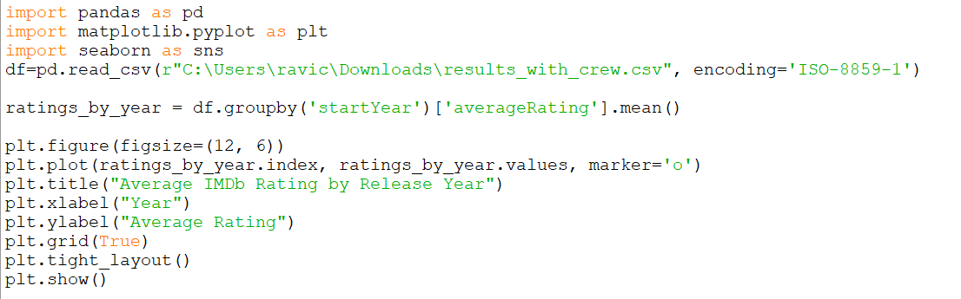

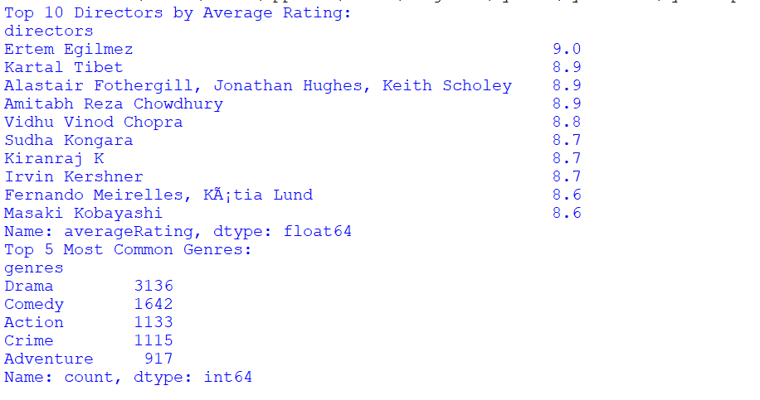
Analysis Result

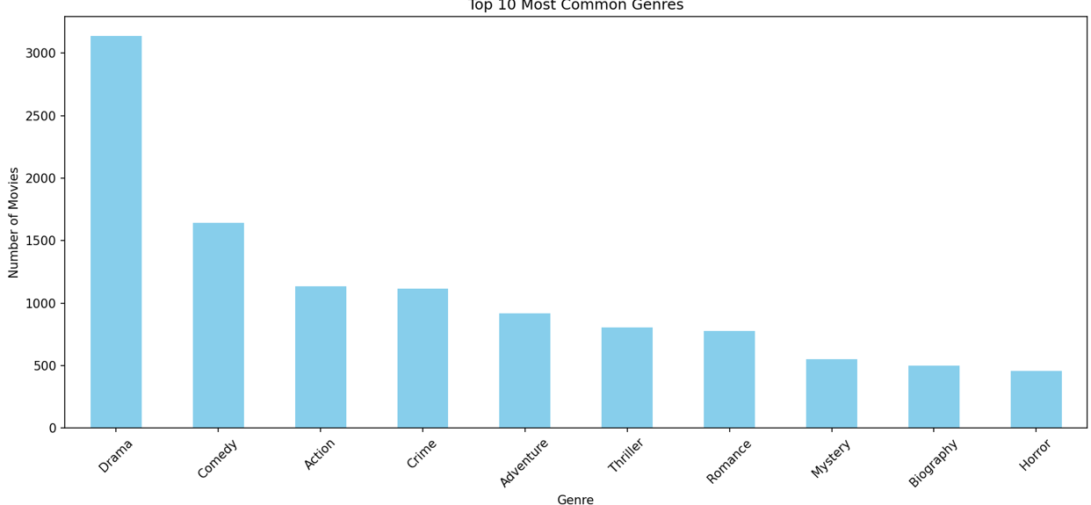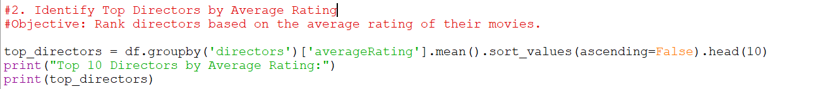

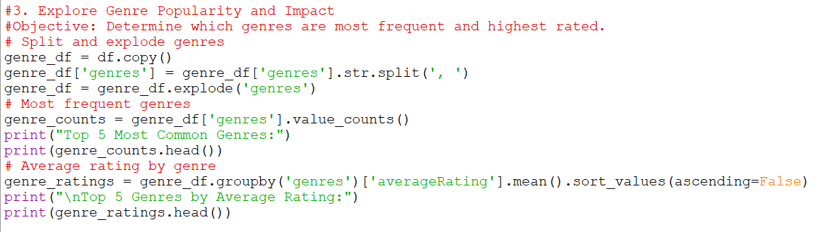
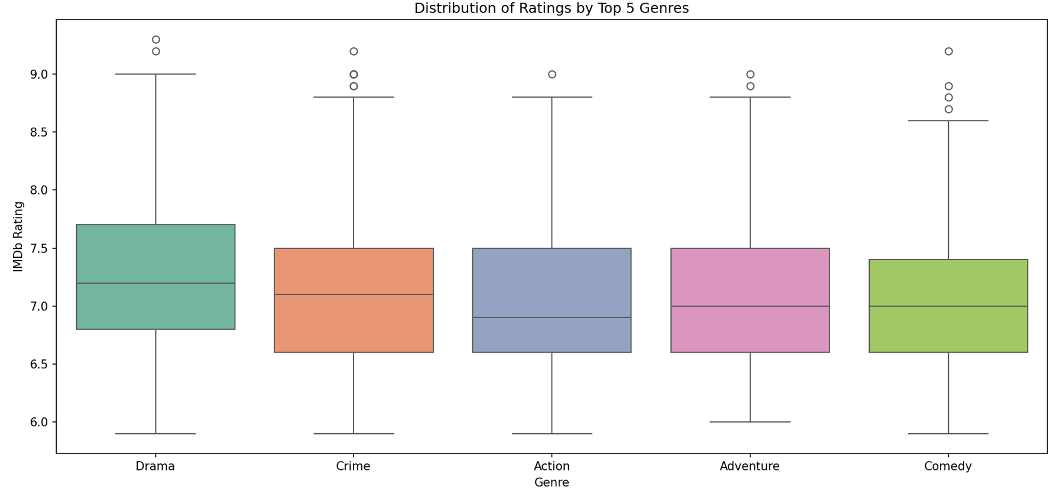

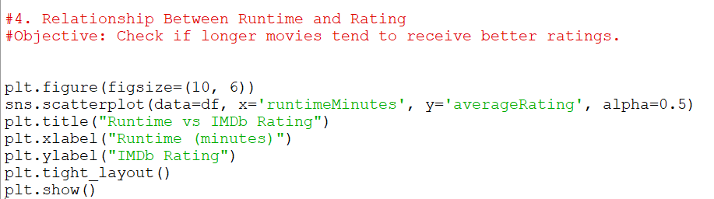
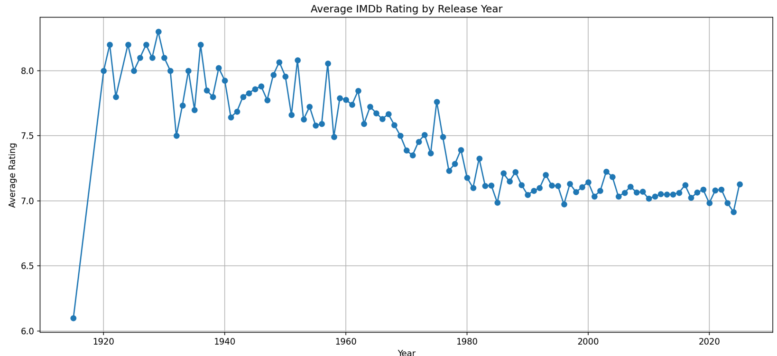

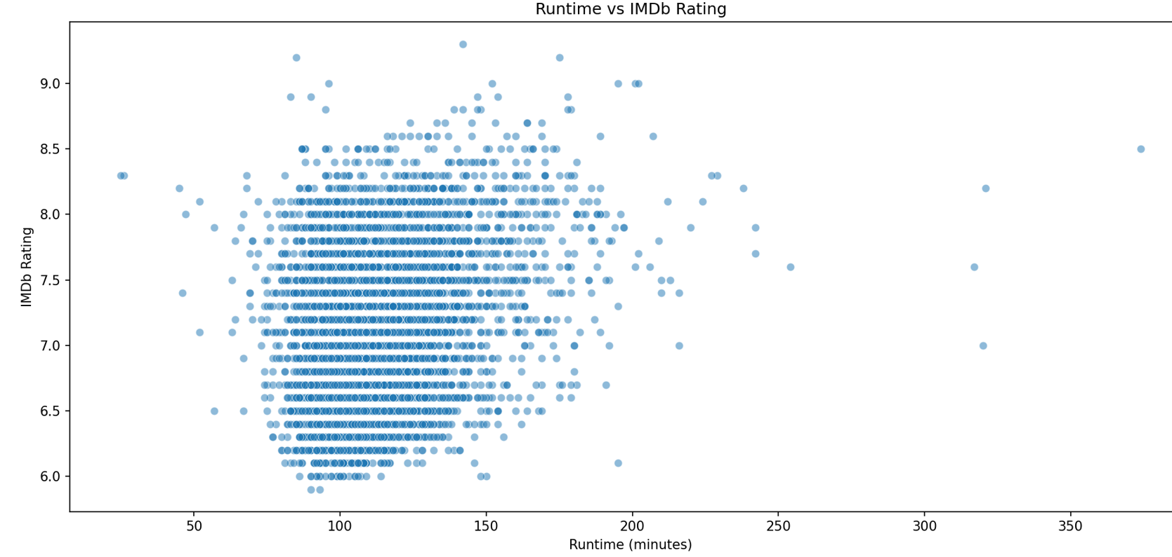
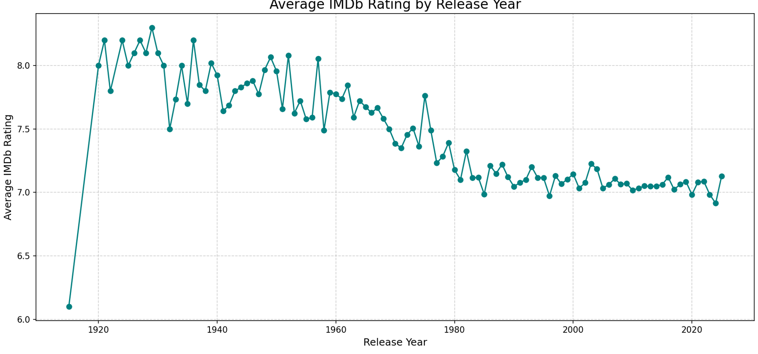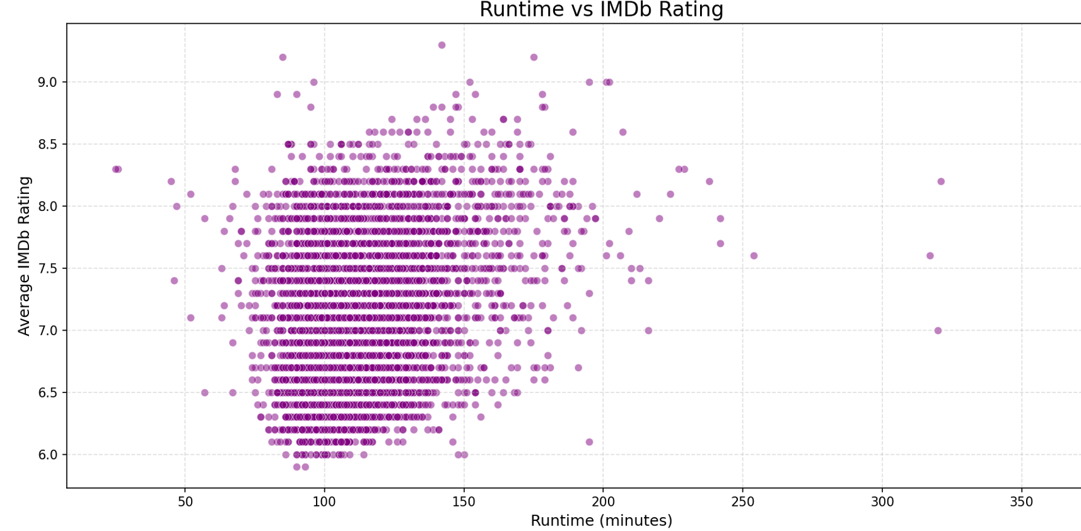
.

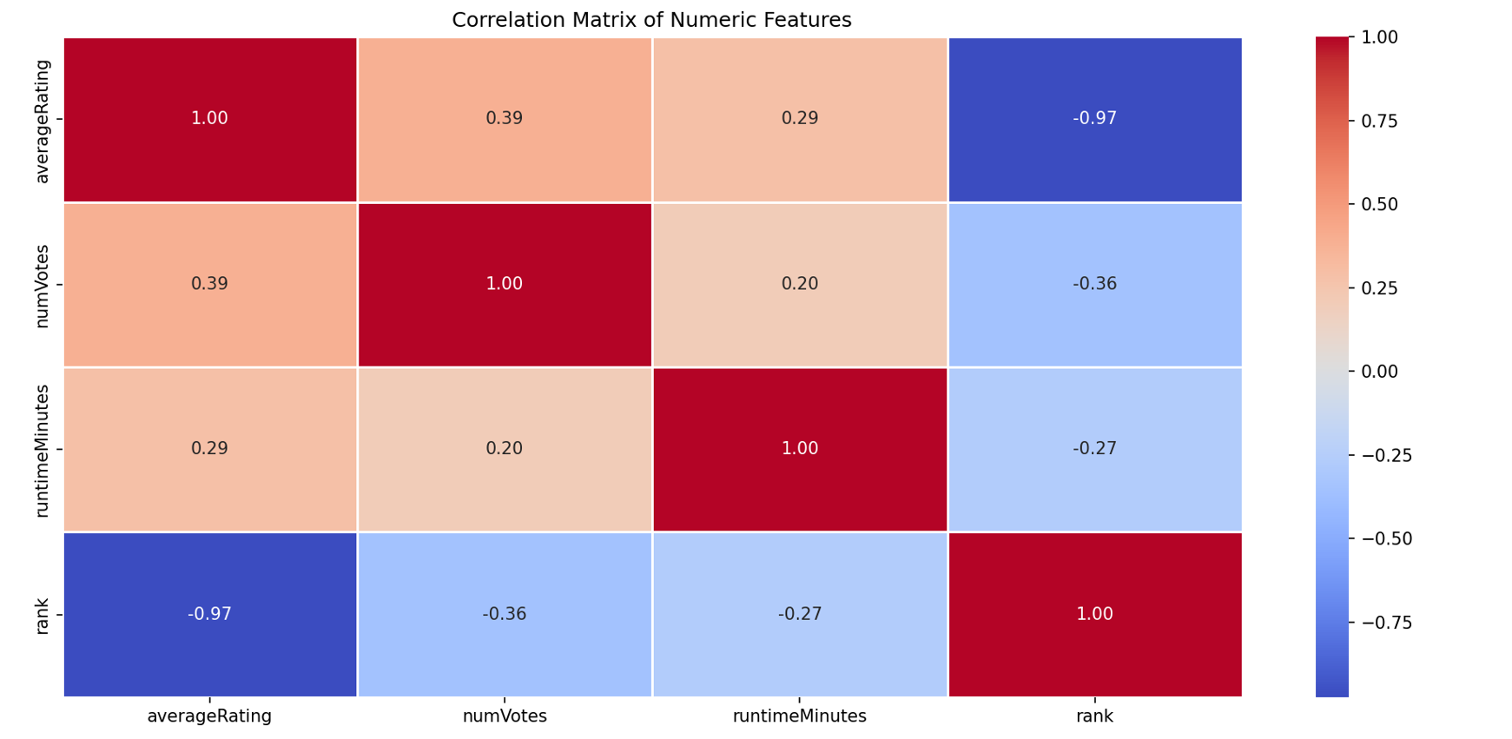
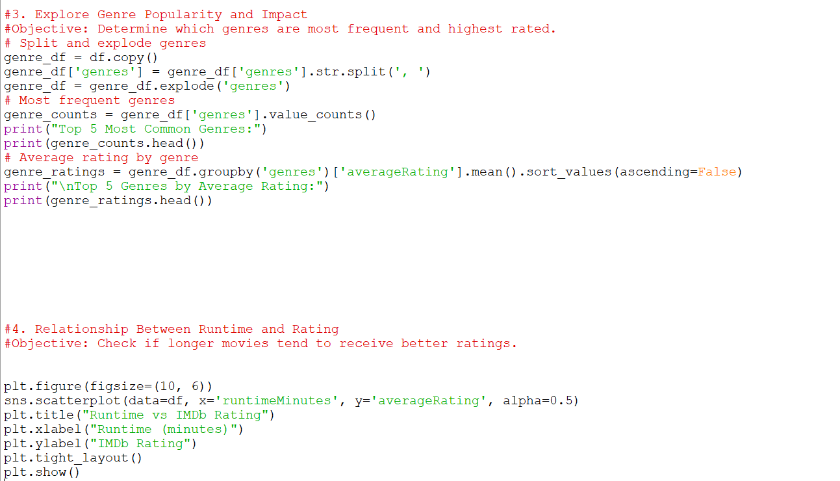
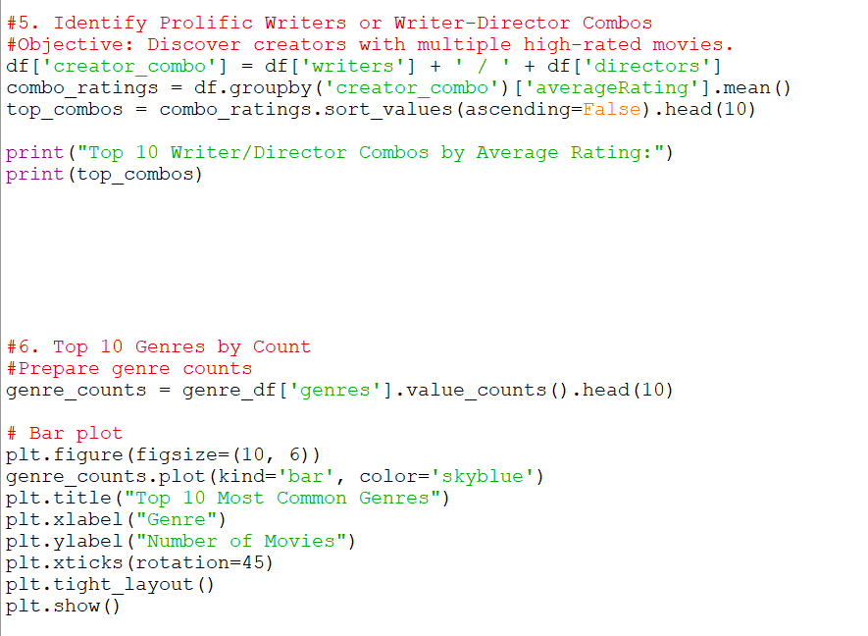
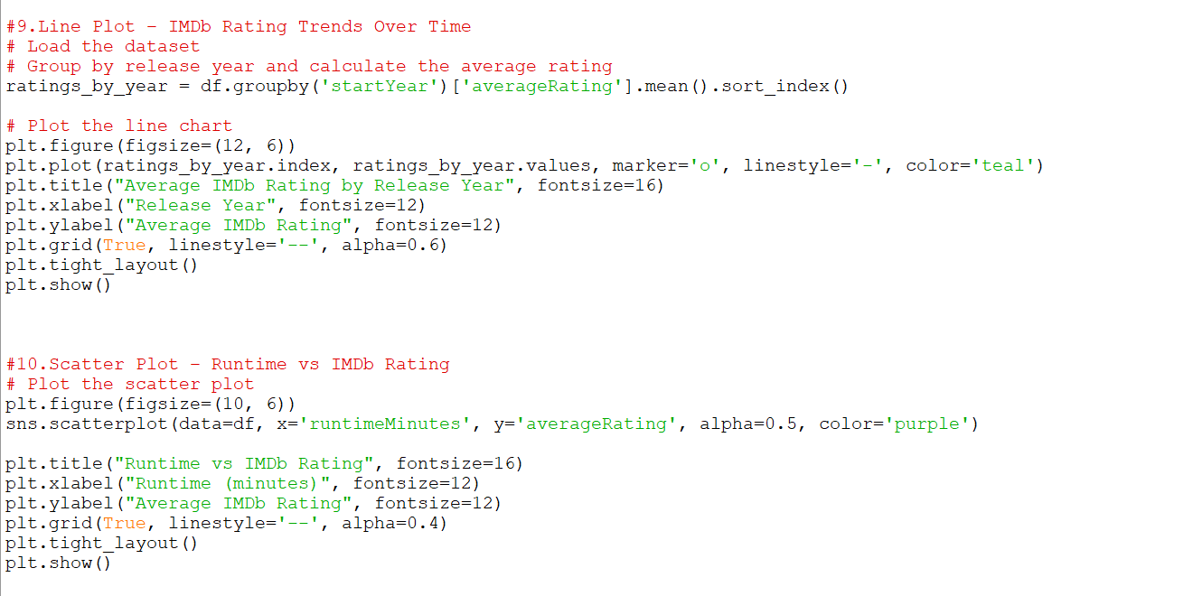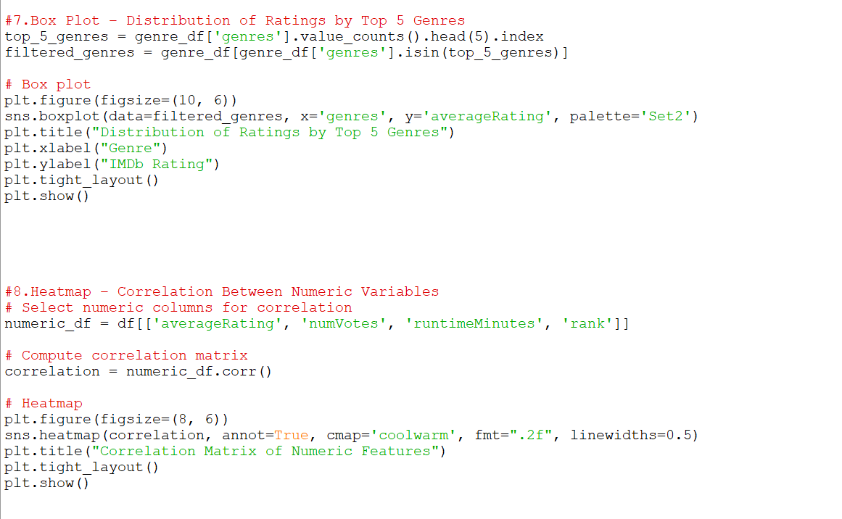

Conclusion

In this project, we conducted an in-depth analysis of 5000 top-rated movies using Python libraries like pandas, matplotlib, and seaborn. The goal was to uncover trends, patterns, and insights from IMDb’s dataset that could explain what makes a movie highly rated.
Key takeaways from the analysis:
- Average Ratings Over the Years
We observed how audience preferences have shifted over time by analyzing the average IMDb ratings by release year. The results showed consistent high ratings during certain periods, hinting at golden eras of filmmaking.
- Genre Trends
Some genres, such as Drama and Action, were dominant among top-rated films. Combinations like "Drama-Thriller" and "Action-Adventure" often had higher average ratings.
- Director & Crew Influence
Renowned directors like Christopher Nolan and Martin Scorsese frequently appeared in top-rated titles, suggesting a strong correlation between directorial style and audience appreciation.
- Runtime vs Rating
While longer runtimes didn’t always guarantee higher ratings, a moderate length (90–150 minutes) was most common among high scorers, indicating an optimal duration for storytelling.
- Yearly Movie Output
In recent decades, there's been a surge in the number of highly rated films, possibly due to improved access to filmmaking tools and global streaming platforms.

Final Thoughts:
Through data-driven exploration, we gained meaningful insights into what defines a top-rated movie. The combination of storytelling, genre, crew quality, and timing seems to play a major role. This kind of analysis not only helps movie enthusiasts and critics but can also guide future filmmakers toward making impactful cinema.

  - Pandas Documentation
  - Matplotlib Documentation
  - Seaborn Documentation
(Used for data cleaning, visualization, and analytical modeling)
